Windows Fundamentals
Task 1: Explore Windows Architecture Using Running Processes
🎯 Goal
Understand how Windows boots, runs applications, and protects critical system components using user mode and kernel mode separation.
🔍 Explanation
Windows is designed with a layered architecture to ensure stability and security.
- User Mode is where applications such as browsers, editors, and desktop programs run. If an application crashes in user mode, it does not crash the entire operating system.
- Kernel Mode is the core of Windows. It manages CPU scheduling, memory management, hardware drivers, and security enforcement. Any failure here results in a Blue Screen of Death (BSOD).
Windows depends on several critical background processes:
- Explorer.exe manages the desktop, Start Menu, and File Explorer.
- LSASS.exe handles authentication and password validation.
- CSRSS.exe manages console windows and critical user-mode operations.
- Win32 Subsystem acts as the interface between applications and the OS.
Understanding these components is essential for troubleshooting and security investigations.
🛠️ Hands-On Exercise
1️⃣ Download and open Process Explorer (Sysinternals).
2️⃣ Expand the process tree and locate explorer.exe.
- Identify its parent process
- Check the user context
- Review loaded DLLs
3️⃣ Locate lsass.exe and observe that it runs as a protected system process.

Task 2: Investigate Windows File System Structure (NTFS)
🎯 Goal
Understand Windows directory layout, NTFS features, and permission boundaries.
🔍 Explanation
Windows uses NTFS (New Technology File System), which provides:
- File permissions using Access Control Lists (ACLs)
- Encryption (EFS)
- Compression
- Journaling for crash recovery
Important directories include:
- C:\Windows\System32 → Core operating system binaries
- C:\Program Files → Installed applications
- C:\Users → User profiles
- AppData → Application configurations, cache, and tokens (critical for forensics)
Both attackers and defenders rely heavily on file system knowledge.
🛠️ Hands-On Exercise
1️⃣ Open File Explorer and navigate to:
C:\Windows\System32
C:\Users\<YourUser>\AppData

2️⃣ Enable Hidden Items to reveal system folders.
3️⃣ Right-click System32 → Properties → Security.
- Identify the owner
- Identify which groups have write access
4️⃣ Search for executable files using:
*.exe

Task 3: Manage Users, Groups & Privileges
🎯 Goal
Understand how Windows controls access and enforces privileges using users and groups.
🔍 Explanation
Windows is a multi-user operating system. Permissions are assigned through user accounts and group memberships.
User types include:
- Administrator → Full system control
- Standard User → Limited privileges
- System Accounts → Used by services (SYSTEM, LOCAL SERVICE)
Security teams monitor user activity to detect unauthorized access and privilege escalation.
🛠️ Hands-On Exercise
List all users:
net user
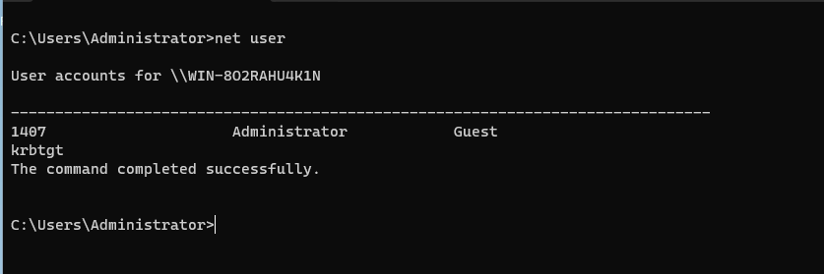

View user details:

net user username
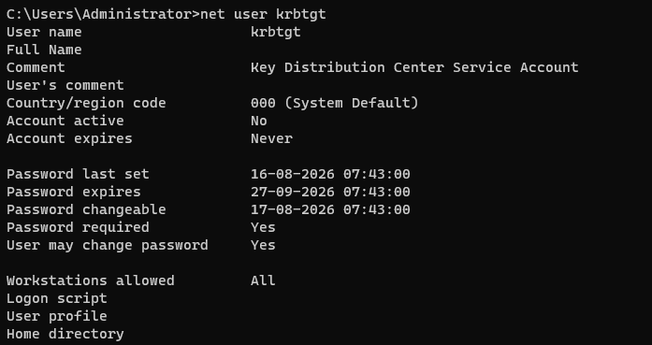
List groups:
net localgroup
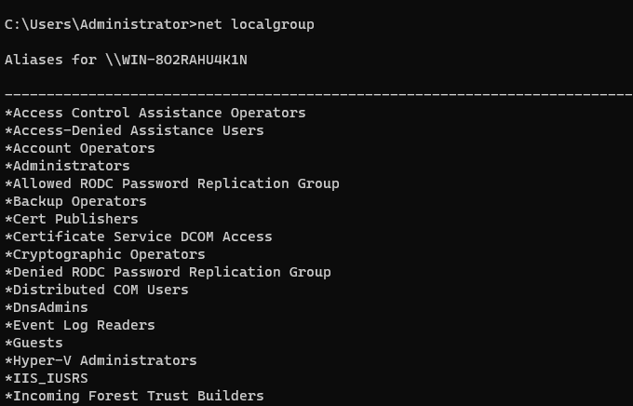

Check your privileges:

whoami
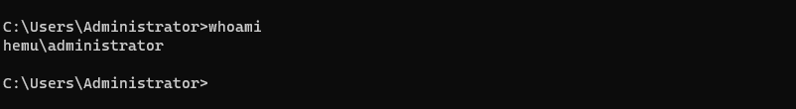
Create a new user:
net user student123 Pass@123 /add
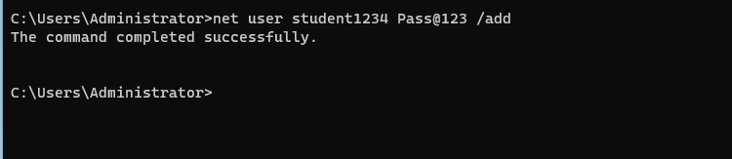
Add user to Administrators:
net localgroup administrators student123 /add

Log in as the new user and attempt a software installation.

Task 4: Analyze Running Processes and Resource Usage
🎯 Goal
Understand how Windows executes programs and allocates system resources.
🔍 Explanation
A process is a running instance of a program. Each process consumes:
- CPU
- Memory
- Disk I/O
- Network resources

Windows uses helper processes such as:
- svchost.exe to host multiple services
- dllhost.exe for COM objects
- csrss.exe for critical system operations
Abnormal process behavior is a key indicator in SOC investigations.
🛠️ Hands-On Exercise
1️⃣ Open Task Manager → Processes.

- Identify the top 5 CPU-consuming processes
- Identify the top 5 memory-consuming processes

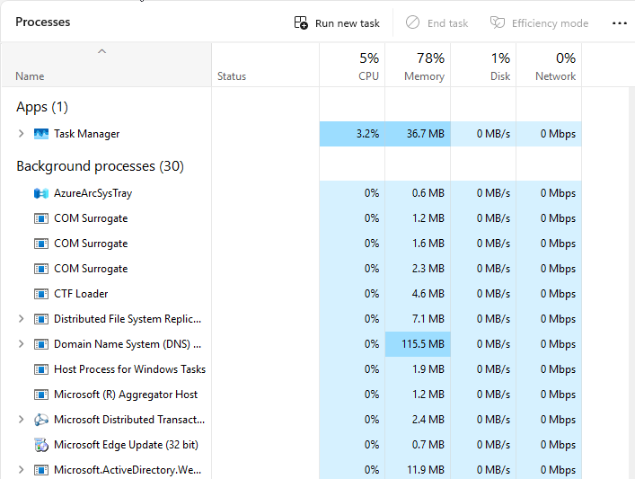

2️⃣ Open Resource Monitor and observe disk and network activity.
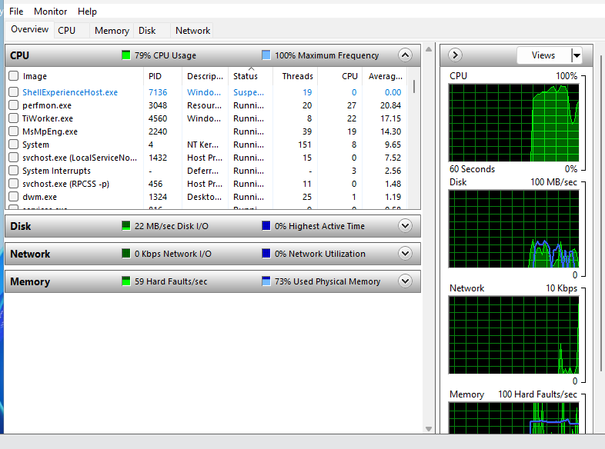

3️⃣ Launch Notepad and terminate it using Task Manager.

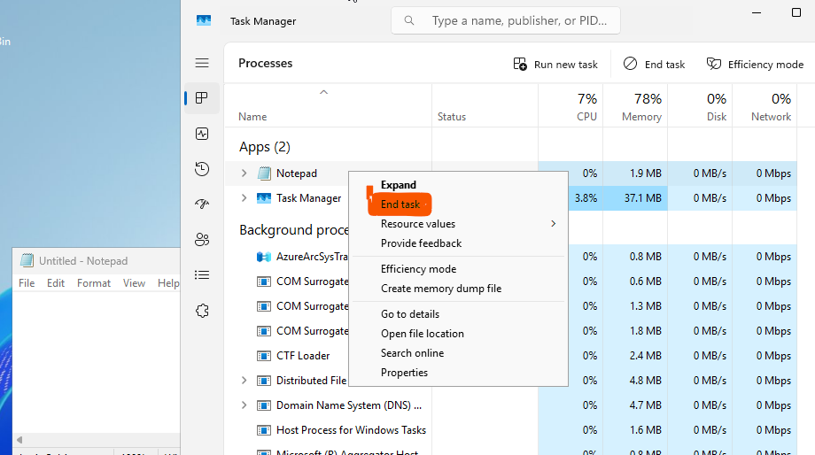

Task 5: Inspect and Control Windows Services
🎯 Goal
Understand how Windows automates background system functions using services.
🔍 Explanation
A Windows service is a background process that supports core OS functionality.
Services can start:
- Automatically
- Manually
- Be disabled
Improperly configured services can affect performance and security.
🛠️ Hands-On Exercise
1️⃣ Open:
services.msc
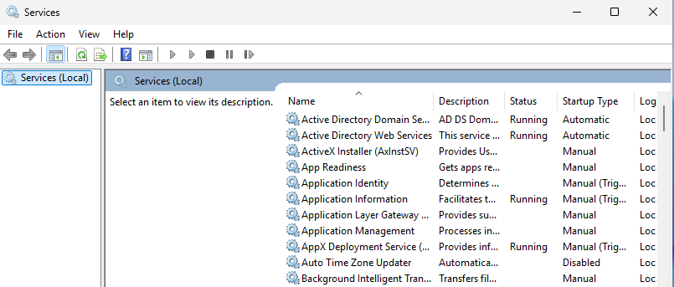

2️⃣ Locate:
- Windows Update
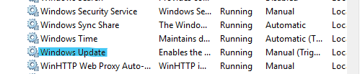
- Windows Defender Antivirus
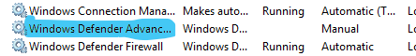
- DHCP Client
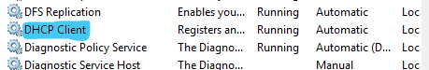
3️⃣ Record:
- Startup type
- Status
- Description
4️⃣ Stop and restart a non-critical service (e.g., Print Spooler).

Task 6: Explore Windows Registry and Startup Entries
🎯 Goal
Understand how Windows stores configuration data and controls startup behavior.
🔍 Explanation
The Windows Registry is a centralized database storing:
- OS configuration
- Application settings
- User preferences
- Startup programs
Important registry hives:
- HKLM → System-wide settings
- HKCU → User-specific settings
- HKCR → File associations
Malware often uses registry keys for persistence.
🛠️ Hands-On Exercise
1️⃣ Open Registry Editor:
regedit
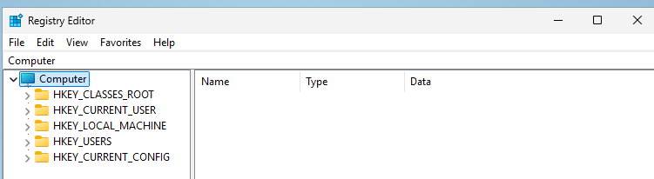
2️⃣ Navigate to:
HKLM\SOFTWARE\Microsoft\Windows\CurrentVersion\Run
3️⃣ Review startup entries.
4️⃣ Create a temporary string value named TestEntry and delete it.

Task 7: Examine Windows Networking Configuration
🎯 Goal
Understand how Windows communicates over a network.
🔍 Explanation
Windows networking relies on:
- IP addressing
- DNS resolution
- Routing tables
- ARP mappings
These details are essential during troubleshooting and incident response.
🛠️ Hands-On Exercise
Run:
ipconfig /all
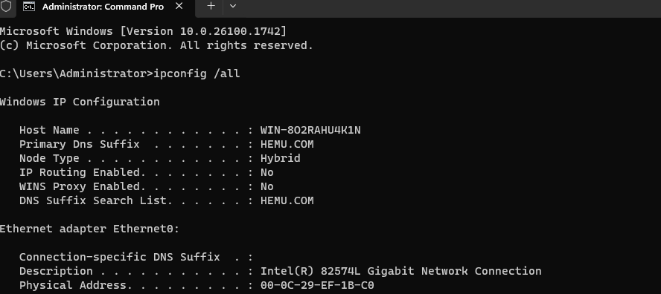
arp -a
netstat -ano

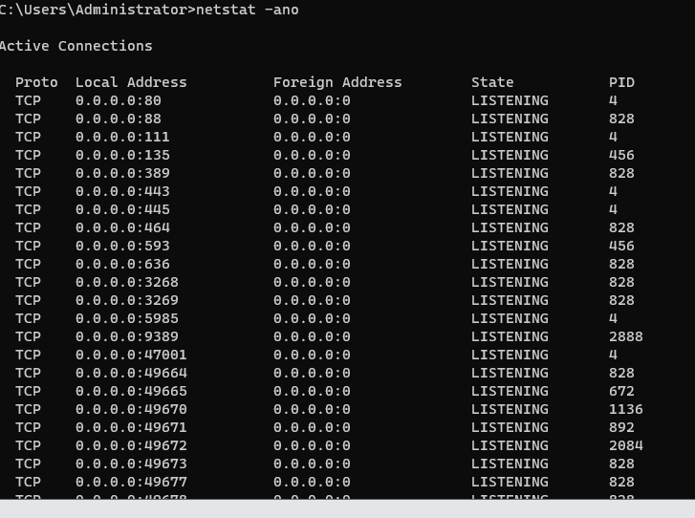

route print
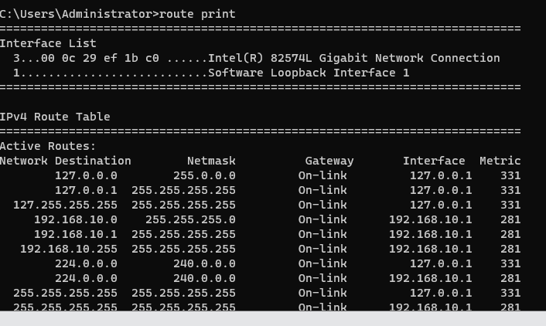
1️⃣ Identify your IPv4 address
2️⃣ Identify DNS servers
3️⃣ Review active network connections
4️⃣ Identify the process listening on port 80 or 443

Task 8: Perform Basic Administration Using PowerShell
🎯 Goal
Build foundational scripting and automation skills using PowerShell.
🔍 Explanation
PowerShell is an object-based shell designed for automation and administration.
It is widely used by administrators and frequently abused by attackers.
🛠️ Hands-On Exercise
Run:
Get-Process
Get-Service
Get-LocalUser
Get-EventLog-LogNameSystem-Newest20

Filter services:
Get-Service | ? {$_.Name-like"Win*"}

Export process data:
Get-Process |Export-Csv processes.csv

Task 9: Investigate Windows Event Logs
🎯 Goal
Understand Windows auditing and authentication trails.
🔍 Explanation
Windows records all security-relevant events, including:
- Logins and logouts
- Process creation
- System failures
- Security alerts
Key Event IDs:
- 4624 → Successful login
- 4625 → Failed login
- 4688 → Process creation
- 1102 → Logs cleared

🛠️ Hands-On Exercise

1️⃣ Open:

eventvwr.msc
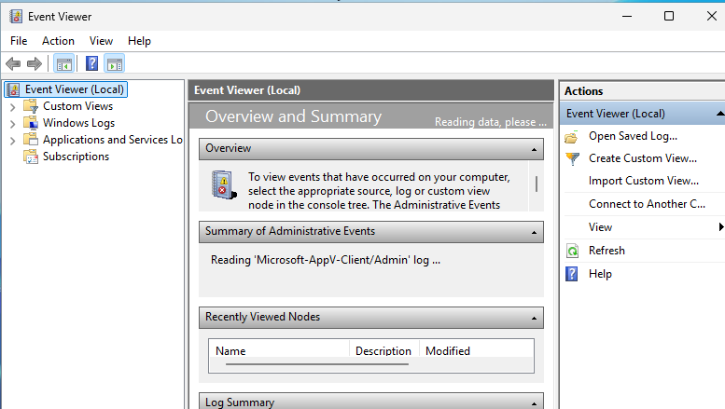
2️⃣ Navigate to Security Logs
3️⃣ Filter Event ID 4624
4️⃣ Identify:
- Username
- Logon type
- Source IP (if remote)

Task 10: Review Built-In Windows Security Controls

🎯 Goal

Understand how Windows protects endpoints by default.

🔍 Explanation

Windows includes built-in security mechanisms such as:
- Microsoft Defender Antivirus
- Windows Firewall
- User Account Control (UAC)
- BitLocker disk encryption
- Account lockout policies
These controls form the foundation of endpoint security.

